SHADNOR FIRST BAPTIST CHURCH
770-964-6105
September 1, 2014

Pastor Rev. Wendell Burdette
Worship Leader Rev. Tommy Worthey
Organist Mrs. Shelby Poucher Pianist Mrs. Patty Burdette Ministry Assistant Mrs. Sherrie Stuart

MORNING WORSHIP
11:00 a.m.

"Be kind and compassionate to one another, forgiving each other, just as in Christ God forgave you." (Ephesians 4:32 )

Prelude Pianist and Organist
Call to Worship 361 "We Have Come Into His House"
Hymn 138 "At Calvary"
Opening Prayer
Hymn 142 "There Is a Fountain"
Welcome and Announcements Rev. Wendell Burdette
Hymn 407 "Because He Lives"
Offering
Offertory Instrumentalists
Fellowship Hymn 344 "Jesus Loves Me"
Communion
Solo - Tommy Worthey "Love Grew Where the Blood Fell"
Message Rev. Wendell Burdette

"The Unity of the Body"
Ephesians 4:1-16

Invitation Hymn 300 "Without Him"
Benediction Hymn 437 "Greater Is He That Is In Me"
Postlude Pianist and Organist

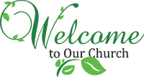
Thank you for joining us for worship today! Each week, we look forward to meeting together and encountering the Lord through worship. If you are a guest, Welcome! Please let us know of your visit by filling out the card located in the pew. Simply drop the card in the offering plate later in the service so that we can follow up with your visit and better serve you. Again, thanks for joining us for this time of worship!

Please welcome our new church Deacon - Norman Jones!

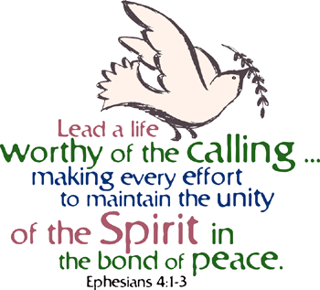




Sunday - September 7, 2014
Communion
Tuesday - September 9, 2014
10:30 AM - WMU Meeting
Wednesday - September 10, 2014
6:30 PM - "40 Days In The Word"- Video #6
Thursday - September 11, 2014
10:30 AM - Lunch Trip to "Buckner's"
Wednesday - September 17, 2014
5:30 PM - Church Supper (BBQ Ribs)
6:30 PM - Church Conference
Wednesday - September 24, 2014
6:30 PM - Bible Study
Wednesday - October 1, 2014
6:30 PM - Bible Study
Wednesday - October 8, 2014
6:30 PM - Bible Study
Monday - October 13, 2014
Columbus Day!

Pastor Contact Information:
Pastor: Rev. Wendell Burdette
Office:770-964-6105; Home: 770-253-8604; Cell: 404-931-3925
Email: WendellBurdette@gmail.com
Website: http://www.shadnorfbc.org

SHADNOR FIRST BAPTIST CHURCH
6320 Westbrook Avenue
Union City, GA 30291
Telephone: 770-964-6105

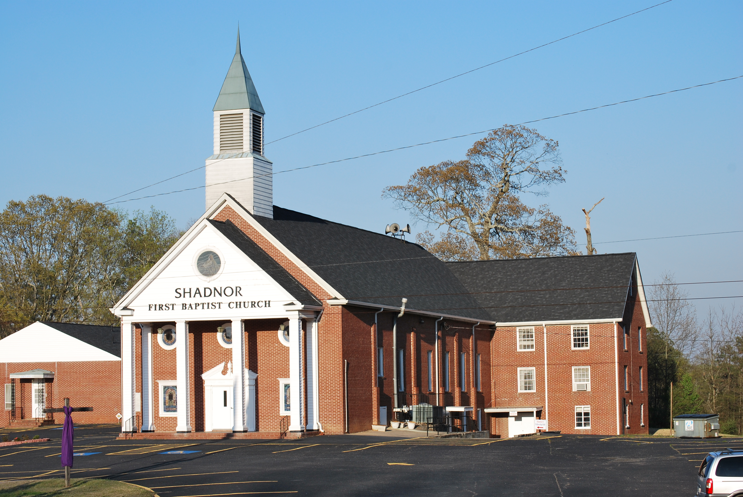

http://www.shadnorfbc.org

