SHADNOR FIRST BAPTIST CHURCH
770-964-6105
September 21, 2014

Pastor Rev. Wendell Burdette
Worship Leader Rev. Tommy Worthey
Organist Mrs. Shelby Poucher Pianist Mrs. Patty Burdette Ministry Assistant Mrs. Sherrie Stuart

MORNING WORSHIP
11:00 a.m.

"If we confess our sins, he is faithful and just and will forgive us our sin sand purify us from all unrighteousness." (1 John 1:9 )

Prelude Pianist and Organist
Call to Worship "There Is Power in the Blood"
Hymn 330 "Amazing Grace! How Sweet the Sound"
Opening Prayer
Hymn 133 "The Blood Will Never Lose It's Power"
Welcome and Announcements Rev. Wendell Burdette
Hymn 595 "Send the Light"
Offering
Offertory Instrumentalists
Fellowship Hymn 592 "Jesus Loves the Little Children"
Special Music

Message Rev. Wendell Burdette

Two Part Series: On Mission to Share Jesus, Part 2 of 2
"Stick By The Stuff"
1 Samuel 25:12-13 & 2 Timothy 2:2

Invitation Hymn 134 "Jesus Paid It All"
Benediction Hymn 23 "God Is So Good"
Postlude Pianist and Organist


Thank you for joining us for worship today! Each week, we look forward to meeting together and encountering the Lord through worship. If you are a guest, Welcome! Please let us know of your visit by filling out the card located in the pew. Simply drop the card in the offering plate later in the service so that we can follow up with your visit and better serve you. Again, thanks for joining us for this time of worship!
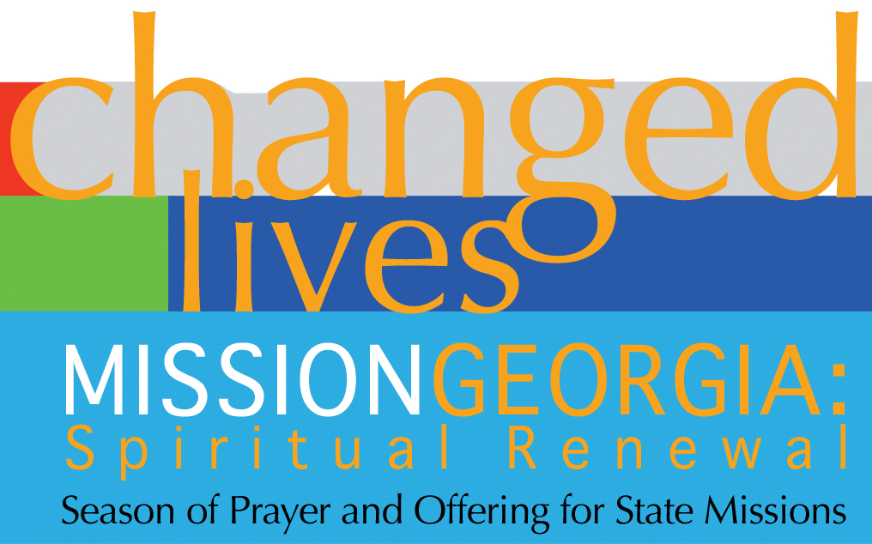
Season of Prayer and Offering for State Missions
Our Church Goal: $400
Received to Date: $145
Type a quote from the document or the summary of an interesting point. You can position the text box anywhere in the document. Use the Text Box Tools tab to change the formatting of the pull quote text box.]





Wednesday - September 24, 2014
6:30 PM - Bible Study
Wednesday - October 1, 2014
6:30 PM - Bible Study
7:15 PM - Deacons' Meeting
Wednesday - October 8, 2014
6:30 PM - Deacon Ordination Service
for: Norman Jones
Monday - October 13, 2014
Columbus Day!
Tuesday - October 14, 2014
10:30 AM - WMU Meeting
Wednesday - October 15, 2014
5:30 PM - Church Supper
6:30 PM - Church Conference
Wednesday - October 22, 2014
6:30 PM - Bible Study
Wednesday - October 29, 2014
6:30 PM - Bible Study
Wednesday - October 31, 2014
Halloween!

Pastor Contact Information:
Pastor: Rev. Wendell Burdette
Office:770-964-6105; Home: 770-253-8604; Cell: 404-931-3925
Email: WendellBurdette@gmail.com
Website: http://www.shadnorfbc.org

SHADNOR FIRST BAPTIST CHURCH
6320 Westbrook Avenue
Union City, GA 30291
Telephone: 770-964-6105

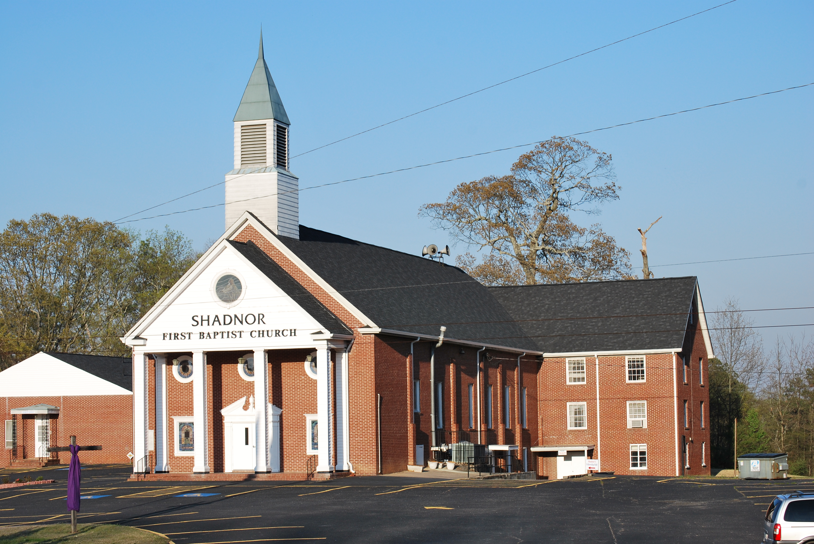

http://www.shadnorfbc.org

