SHADNOR FIRST BAPTIST CHURCH
770-964-6105
September 14, 2014

Pastor Rev. Wendell Burdette
Worship Leader Rev. Tommy Worthey
Organist Mrs. Shelby Poucher Pianist Mrs. Patty Burdette Ministry Assistant Mrs. Sherrie Stuart

MORNING WORSHIP
11:00 a.m.

"Do not let any unwholesome talk come out of your mouths, but only what is helpful for building others up according to their needs, that it may benefit those who listen." (Ephesians 4:29 )

Prelude Pianist and Organist
Call to Worship "Let's Just Praise the Lord"
Hymn 540 "Saved, Saved"
Opening Prayer
Hymn 572 "I Love to Tell the Story"
Welcome and Announcements Rev. Wendell Burdette
Hymn 516 "When the Roll Is Called Up Yonder"
Offering
Offertory Instrumentalists
Choir "Keep on the Firing Line"
Fellowship Hymn 569 "Make Me a Blessing"

Message Rev. Wendell Burdette

Two Part Series: On Mission to Share Jesus, Part 1 of 2
"What Makes Us Go?"
Romans 1:14-16

Invitation Hymn 600 "More About Jesus"
Benediction Hymn "The Old Time Religion"
Postlude Pianist and Organist


Thank you for joining us for worship today! Each week, we look forward to meeting together and encountering the Lord through worship. If you are a guest, Welcome! Please let us know of your visit by filling out the card located in the pew. Simply drop the card in the offering plate later in the service so that we can follow up with your visit and better serve you. Again, thanks for joining us for this time of worship!

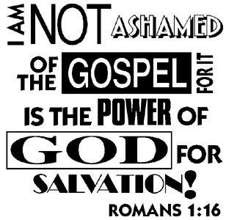




Wednesday - September 17, 2014
5:30 PM - Church Supper (BBQ Ribs)
6:30 PM - Church Conference
Wednesday - September 24, 2014
6:30 PM - Bible Study
Wednesday - October 1, 2014
6:30 PM - Bible Study
7:15 PM - Deacons' Meeting
Wednesday - October 8, 2014
6:30 PM - Deacon Ordination Service
for: Norman Jones
Monday - October 13, 2014
Columbus Day!
Tuesday - October 14, 2014
10:30 AM - WMU Meeting
Wednesday - October 15, 2014
5:30 PM - Church Supper
6:30 PM - Church Conference
Wednesday - October 22, 2014
6:30 PM - Bible Study

Pastor Contact Information:
Pastor: Rev. Wendell Burdette
Office:770-964-6105; Home: 770-253-8604; Cell: 404-931-3925
Email: WendellBurdette@gmail.com
Website: http://www.shadnorfbc.org

SHADNOR FIRST BAPTIST CHURCH
6320 Westbrook Avenue
Union City, GA 30291
Telephone: 770-964-6105

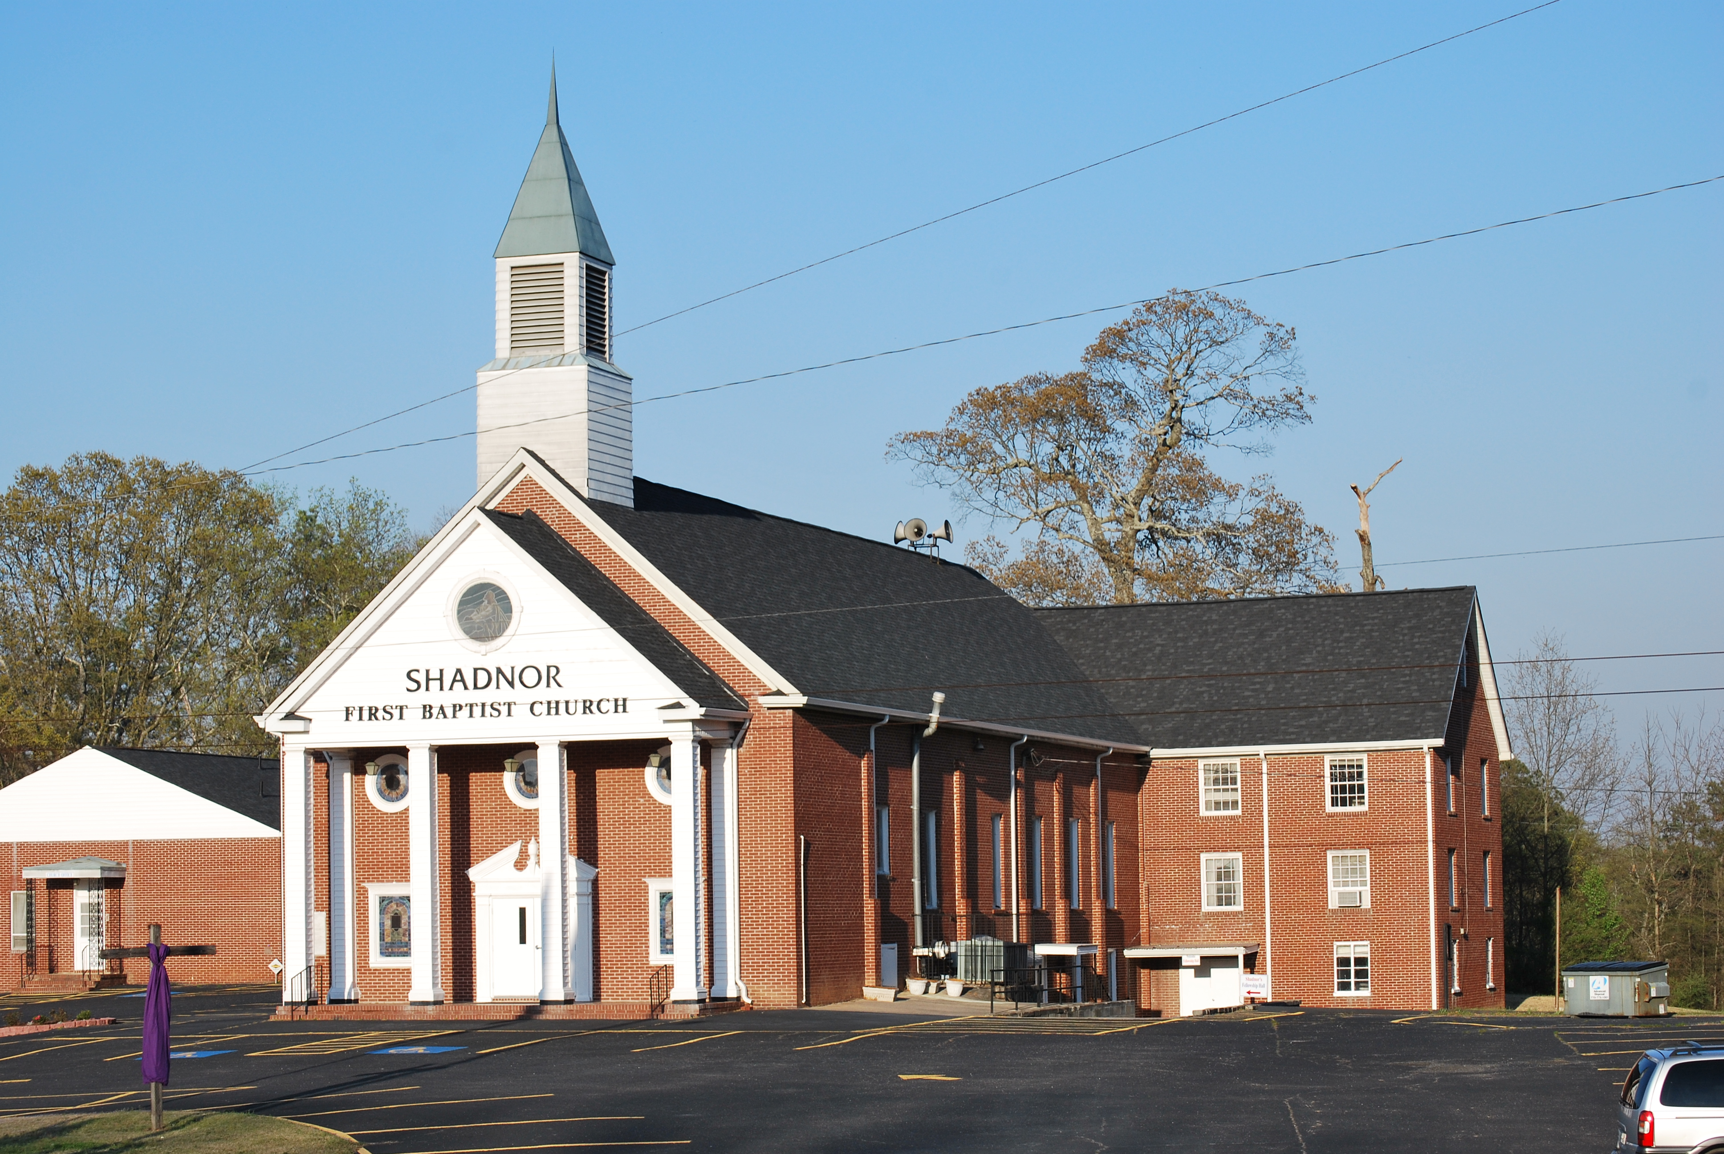

http://www.shadnorfbc.org

