SHADNOR FIRST BAPTIST CHURCH
770-964-6105
October 26, 2014

Pastor Rev. Wendell Burdette
Worship Leader Rev. Tommy Worthey
Organist Mrs. Shelby Poucher Pianist Mrs. Patty Burdette Ministry Assistant Mrs. Sherrie Stuart

MORNING WORSHIP
11:00 a.m.

"Is anyone among you in trouble? Let them pray. Is anyone happy? Let them sing songs of praise" ( James 5:13 )

Prelude Pianist and Organist
Call to Worship "Thy Loving Kindness"
Hymn 407 "Because He Lives"
Opening Prayer
Hymn 64 "God Will Take Care of You"
Welcome and Announcements Rev. Wendell Burdette
Hymn 485 "Stand Up, Stand Up for Jesus"
Offering
Offertory Instrumentalists
Fellowship Hymn 466 "Send a Great Revival"
Special Music

Message Rev. Wendell Burdette

"Barnabas - Encourager"
Acts 4:32-37 & 11:19-26

Invitation Hymn 450 "I Need Thee Every Hour"
Benediction Hymn 253
"Praise God, from Whom All Blessings Flow"

Postlude Pianist and Organist


Thank you for joining us for worship today! Each week, we look forward to meeting together and encountering the Lord through worship. If you are a guest, Welcome! Please let us know of your visit by filling out the card located in the pew. Simply drop the card in the offering plate later in the service so that we can follow up with your visit and better serve you. Again, thanks for joining us for this time of worship!

Don't forget to set your clocks back one hour on Saturday night, Nov. 1st, before you go to bed! Daylight Savings Time Ends on Sunday, Nov. 2nd!






Wednesday - October 29, 2014
6:30 PM - Bible Study
Wednesday - October 31, 2014
Halloween!
Sunday - November 2, 2014
Daylight Savings Time Ends!
Turn Your Clocks Back One Hour!
Wednesday - November 5, 2014
6:30 PM - Bible Study
7:15 PM - Deacons' Meeting
Tuesday - November 11, 2014
10:30 AM - WMU Meeting
Veteran's Day!
Wednesday - November 12, 2014
6:30 PM - Bible Study
Wednesday - November 19, 2014
5:30 PM - Church Supper
6:30 PM - Church Conference

Pastor Contact Information:
Pastor: Rev. Wendell Burdette
Office:770-964-6105; Home: 770-253-8604;
Cell: 404-931-3925
Email: WendellBurdette@gmail.com
Website: http://www.shadnorfbc.org

SHADNOR FIRST BAPTIST CHURCH
6320 Westbrook Avenue
Union City, GA 30291
Telephone: 770-964-6105

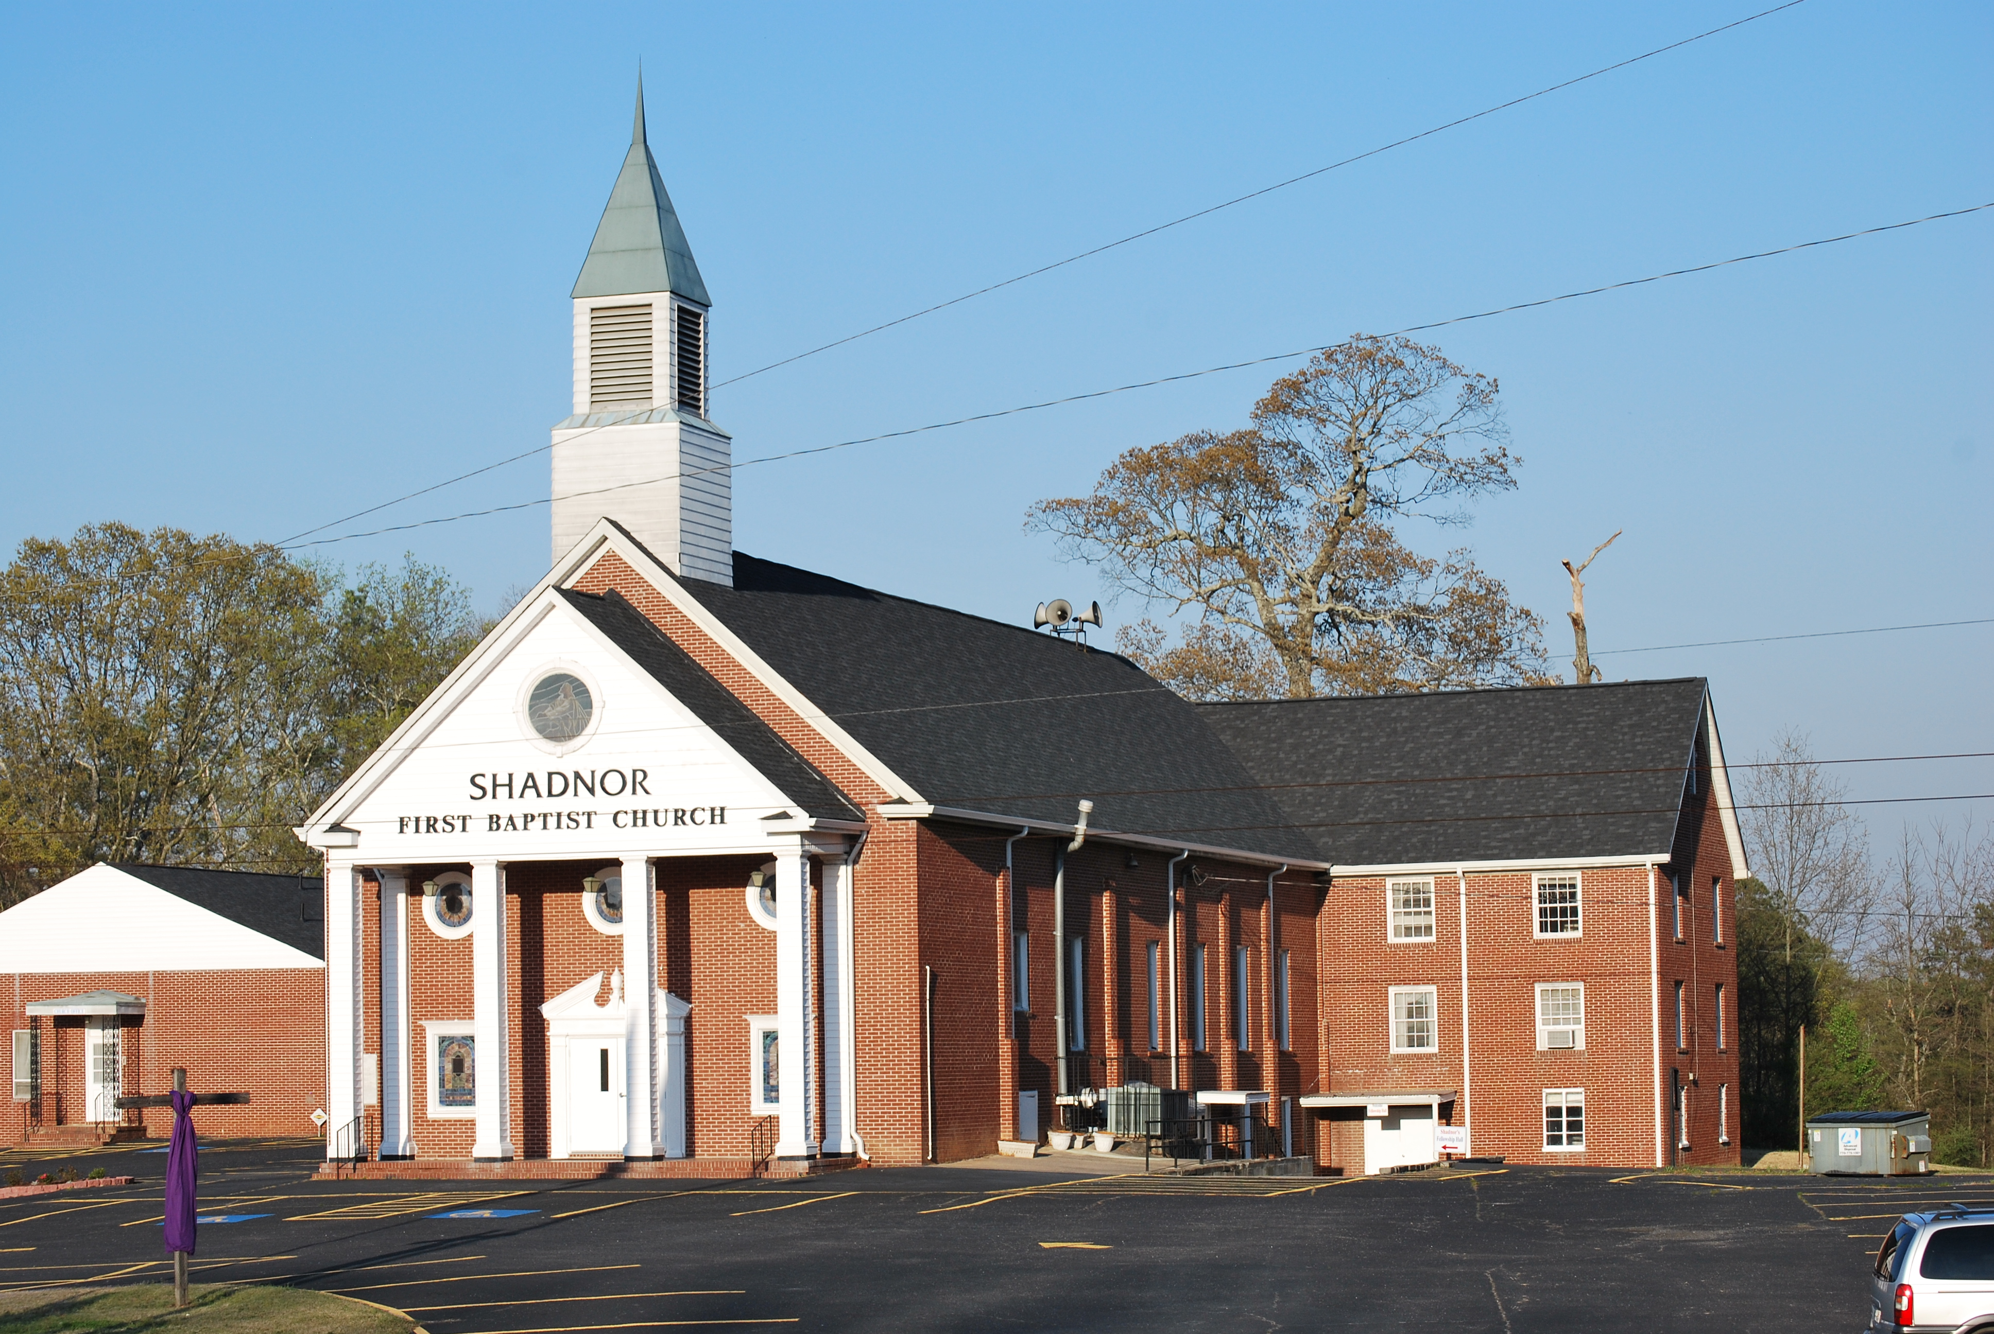

http://www.shadnorfbc.org

