SHADNOR FIRST BAPTIST CHURCH
770-964-6105
October 19, 2014

Pastor Rev. Wendell Burdette
Worship Leader Rev. Tommy Worthey
Organist Mrs. Shelby Poucher Pianist Mrs. Patty Burdette Ministry Assistant Mrs. Sherrie Stuart

MORNING WORSHIP
11:00 a.m.

"It is for freedom that Christ has set us free. Stand firm, then, and do not let yourselves be burdened again by a yoke of slavery" ( Galatians 5:1 )

Prelude Pianist and Organist
Call to Worship "Holy, Holy, Holy"
Hymn 4 "To God Be the Glory"
Opening Prayer
Hymn 338 "How Firm a Foundation"
Welcome and Announcements Rev. Wendell Burdette
Hymn 261 "Wonderful Words of Life"
Offering
Offertory Instrumentalists
Fellowship Hymn 333 "Leaning on the Everlasting Arms"
Special Music Nathan Burdette

Message Rev. Wendell Burdette

"God's Word Will Stand Forever"
Matthew 24:35 & John 8:31-32

Invitation Hymn 307 "Just As I Am"
Benediction Hymn 457 "Lord, Be Glorified"

Postlude Pianist and Organist


Thank you for joining us for worship today! Each week, we look forward to meeting together and encountering the Lord through worship. If you are a guest, Welcome! Please let us know of your visit by filling out the card located in the pew. Simply drop the card in the offering plate later in the service so that we can follow up with your visit and better serve you. Again, thanks for joining us for this time of worship!
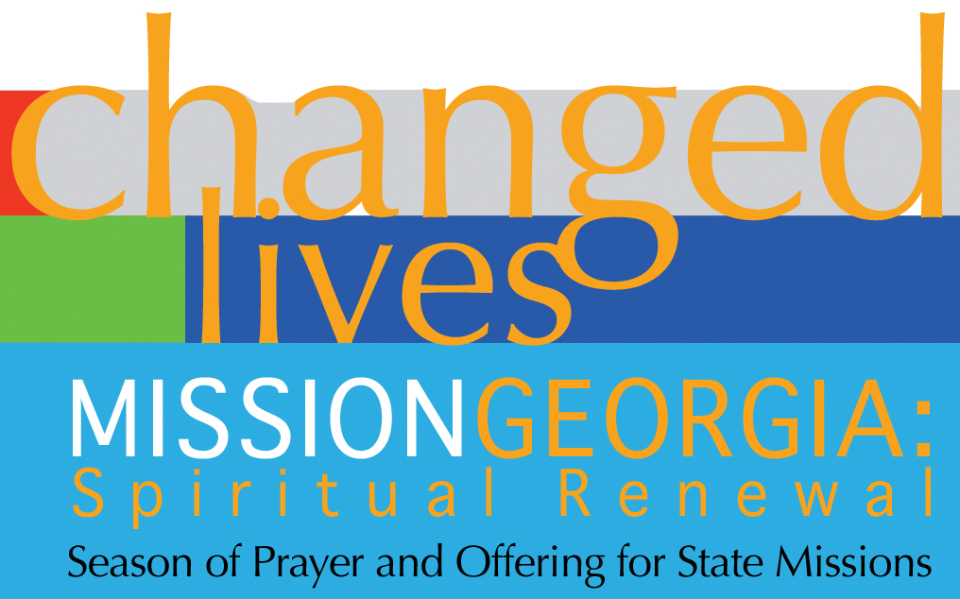
Season of Prayer and Offering for State Missions
Our Church Goal: $400
Received to Date: $235

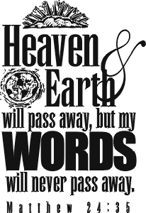




Wednesday - October 22, 2014
6:30 PM - Bible Study
Wednesday - October 29, 2014
6:30 PM - Bible Study
Wednesday - October 31, 2014
Halloween!
Sunday - November 2, 2014
Daylight Savings Time Ends!
Turn Your Clocks Back One Hour!
Wednesday - November 5, 2014
6:30 PM - Bible Study
7:15 PM - Deacons' Meeting
Tuesday - November 11, 2014
10:30 AM - WMU Meeting
Veteran's Day!
Wednesday - November 12, 2014
6:30 PM - Bible Study

Pastor Contact Information:
Pastor: Rev. Wendell Burdette
Office:770-964-6105; Home: 770-253-8604;
Cell: 404-931-3925
Email: WendellBurdette@gmail.com
Website: http://www.shadnorfbc.org

SHADNOR FIRST BAPTIST CHURCH
6320 Westbrook Avenue
Union City, GA 30291
Telephone: 770-964-6105

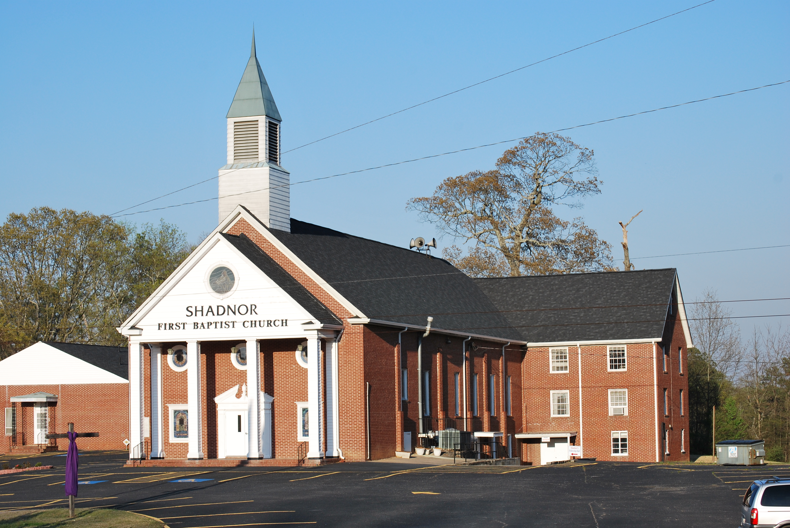

http://www.shadnorfbc.org

