SHADNOR FIRST BAPTIST CHURCH
770-964-6105
October 12, 2014

Pastor Rev. Wendell Burdette
Worship Leader Rev. Tommy Worthey
Organist Mrs. Shelby Poucher Pianist Mrs. Patty Burdette Ministry Assistant Mrs. Sherrie Stuart

MORNING WORSHIP
11:00 a.m.

"Encourage one another daily, as long as it is called Today, so that none of you may be hardened by sin's deceitfulness" ( Hebrews 3:13 )

Prelude Pianist and Organist
Call to Worship "When the Roll Is Called Up Yonder"
Hymn 544 "Redeemed, How I Love to Proclaim It"
Opening Prayer
Hymn 455 "Sweet Hour of Prayer"
Welcome and Announcements Rev. Wendell Burdette
Hymn 521 "On Jordan's Stormy Banks"
Offering
Offertory Instrumentalists
Choir "Ivory Palaces"
Fellowship Hymn 187 "In the Garden"

Message Rev. Wendell Burdette

"Eternal Life, Abundant Life"
John 14:1-6

Invitation Hymn 290 "I Am Thine, O Lord"
Benediction Hymn 515
"There's a land That Is Fairer Than Day"

Postlude Pianist and Organist


Thank you for joining us for worship today! Each week, we look forward to meeting together and encountering the Lord through worship. If you are a guest, Welcome! Please let us know of your visit by filling out the card located in the pew. Simply drop the card in the offering plate later in the service so that we can follow up with your visit and better serve you. Again, thanks for joining us for this time of worship!
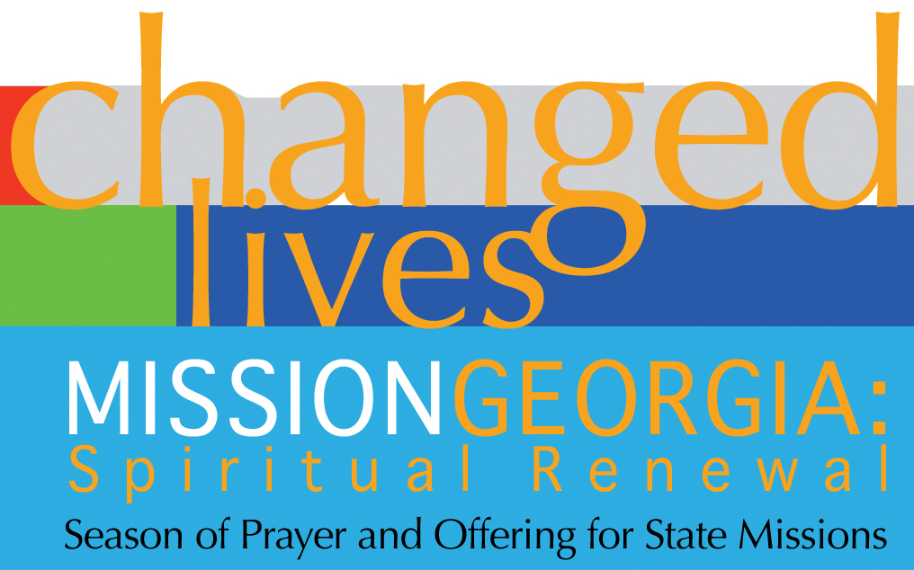
Season of Prayer and Offering for State Missions
Our Church Goal: $400
Received to Date: $235

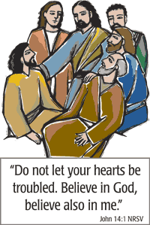

Thank you so much for all your kind words, cards, visits and calls during my recent hospital stay. Your thoughts and prayers kept my spirits lifted. Love in Christ, Ruth Holt




Monday - October 13, 2014
Columbus Day!
Tuesday - October 14, 2014
10:30 AM - WMU Meeting
Wednesday - October 15, 2014
5:30 PM - Church Supper
6:30 PM - Church Conference
Wednesday - October 22, 2014
6:30 PM - Bible Study
Wednesday - October 29, 2014
6:30 PM - Bible Study
Wednesday - October 31, 2014
Halloween!
Sunday - November 2, 2014
Daylight Savings Time Ends!
Turn Your Clocks Back One Hour!
Wednesday - November 5, 2014
6:30 PM - Bible Study
7:15 PM - Deacons' Meeting

Pastor Contact Information:
Pastor: Rev. Wendell Burdette
Office:770-964-6105; Home: 770-253-8604; Cell: 404-931-3925
Email: WendellBurdette@gmail.com
Website: http://www.shadnorfbc.org

SHADNOR FIRST BAPTIST CHURCH
6320 Westbrook Avenue
Union City, GA 30291
Telephone: 770-964-6105

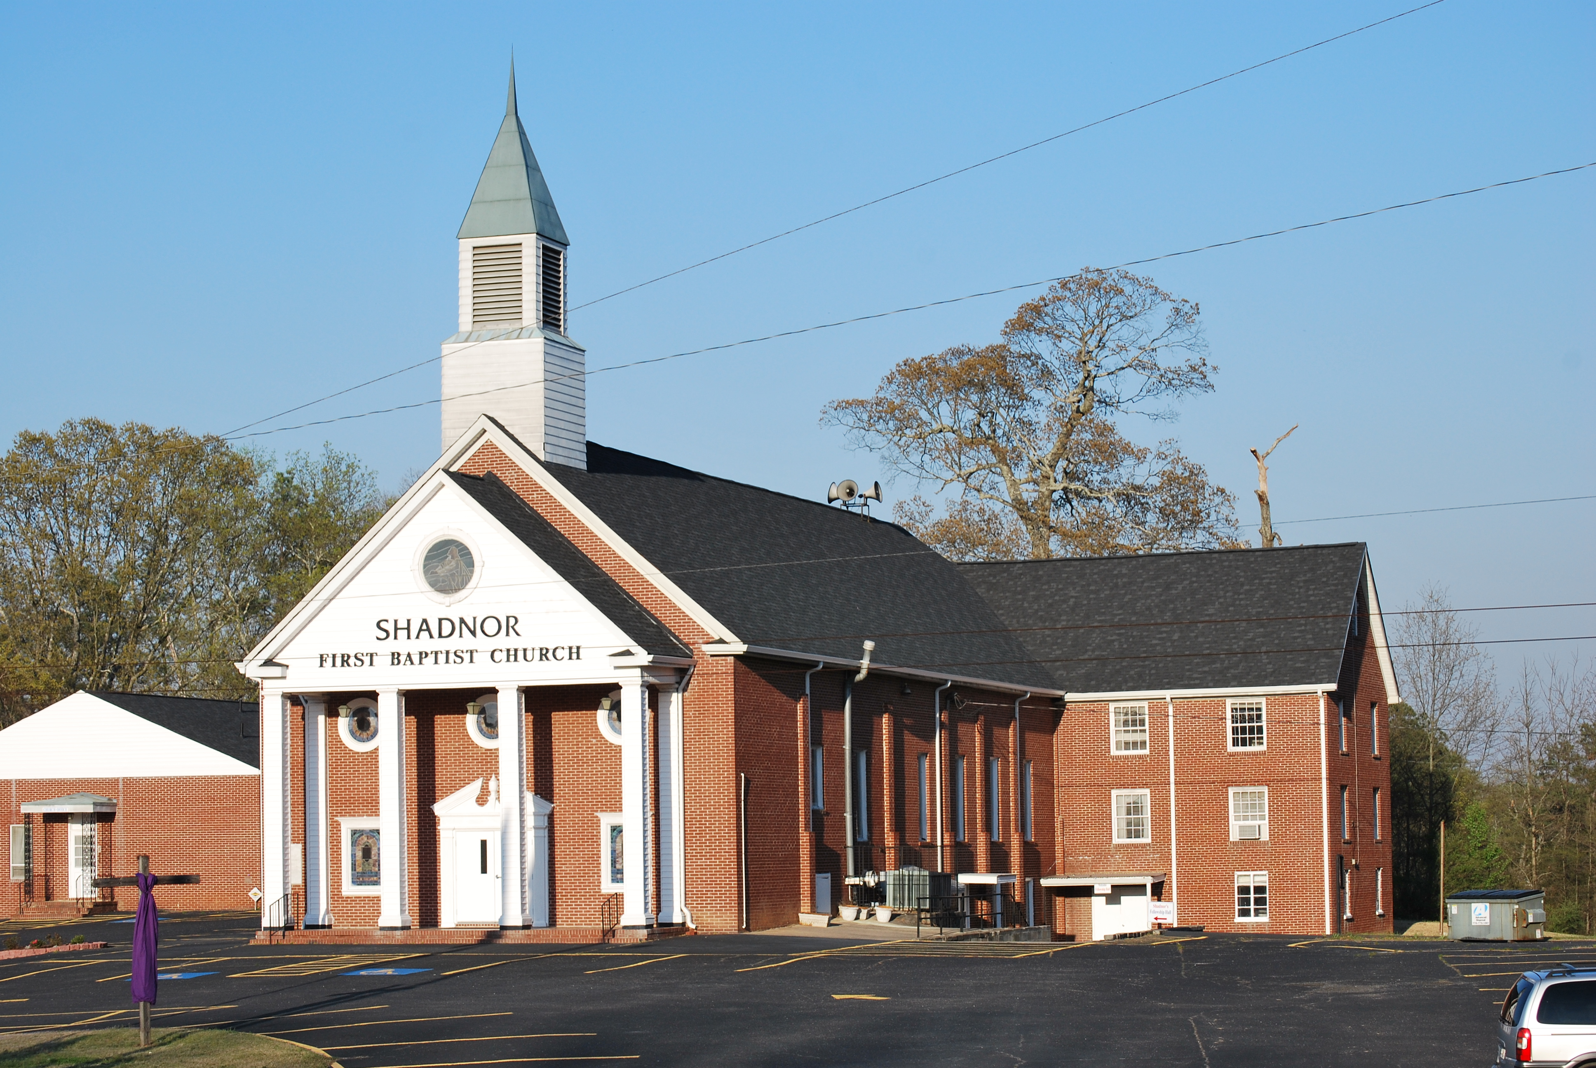

http://www.shadnorfbc.org

