SHADNOR FIRST BAPTIST CHURCH
770-964-6105
November 9, 2014

Pastor Rev. Wendell Burdette
Worship Leader Rev. Tommy Worthey
Organist Mrs. Shelby Poucher Pianist Mrs. Patty Burdette Ministry Assistant Mrs. Sherrie Stuart

MORNING WORSHIP
11:00 a.m.

"He who stands firm to the end will be saved" ( Matthew 24:13 )

Prelude Pianist and Organist
Call to Worship "All Hail the Power of Jesus' Name"
Hymn 206 "Blessed Be the Name"
Opening Prayer
Hymn 329 "Grace Greater than Our Sin"
Welcome and Announcements Rev. Wendell Burdette
Hymn 540 "Saved, Saved"
Offering
Offertory Instrumentalists
Fellowship Hymn 514 "When We All Get to Heaven"
Special Music

Message Rev. Wendell Burdette

"Heavenly Rewards"
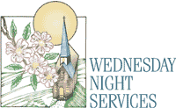
We will start meeting at 4:30PM on Wednesday Nights instead of our normal time of 6:30PM until Mid-March during the Winter months.
Matthew 6:19-21 & Ephesians 2:8-10

Invitation Hymn 320 "Turn Your Eyes Upon Jesus"
Benediction Hymn 584 "We Have Heard the Joyful Sound"

Postlude Pianist and Organist


Thank you for joining us for worship today! Each week, we look forward to meeting together and encountering the Lord through worship. If you are a guest, Welcome! Please let us know of your visit by filling out the card located in the pew. Simply drop the card in the offering plate later in the service so that we can follow up with your visit and better serve you. Again, thanks for joining us for this time of worship!

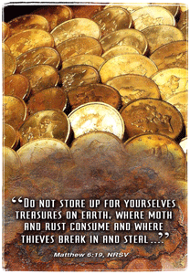




Tuesday - November 11, 2014
10:30 AM - WMU Meeting
Veteran's Day!
Wednesday - November 12, 2014
4:30 PM - Bible Study
Wednesday - November 19, 2014
4:30 PM - Church Supper
5:30 PM - Church Conference
Sunday - November 23, 2014
11:00 AM - Communion!
Wednesday - November 26, 2014
No Mid-Week Services
Thursday - November 27, 2014
Thanksgiving Day!
Dec. 1-7 Week of Prayer for Lottie Moon
International Missions - Our Goal - $1300
Wednesday - December 3, 2014
4:30 PM - Bible Study

Pastor Contact Information:
Pastor: Rev. Wendell Burdette
Office:770-964-6105; Home: 770-253-8604;
Cell: 404-931-3925
Email: WendellBurdette@gmail.com
Website: http://www.shadnorfbc.org

SHADNOR FIRST BAPTIST CHURCH
6320 Westbrook Avenue
Union City, GA 30291
Telephone: 770-964-6105

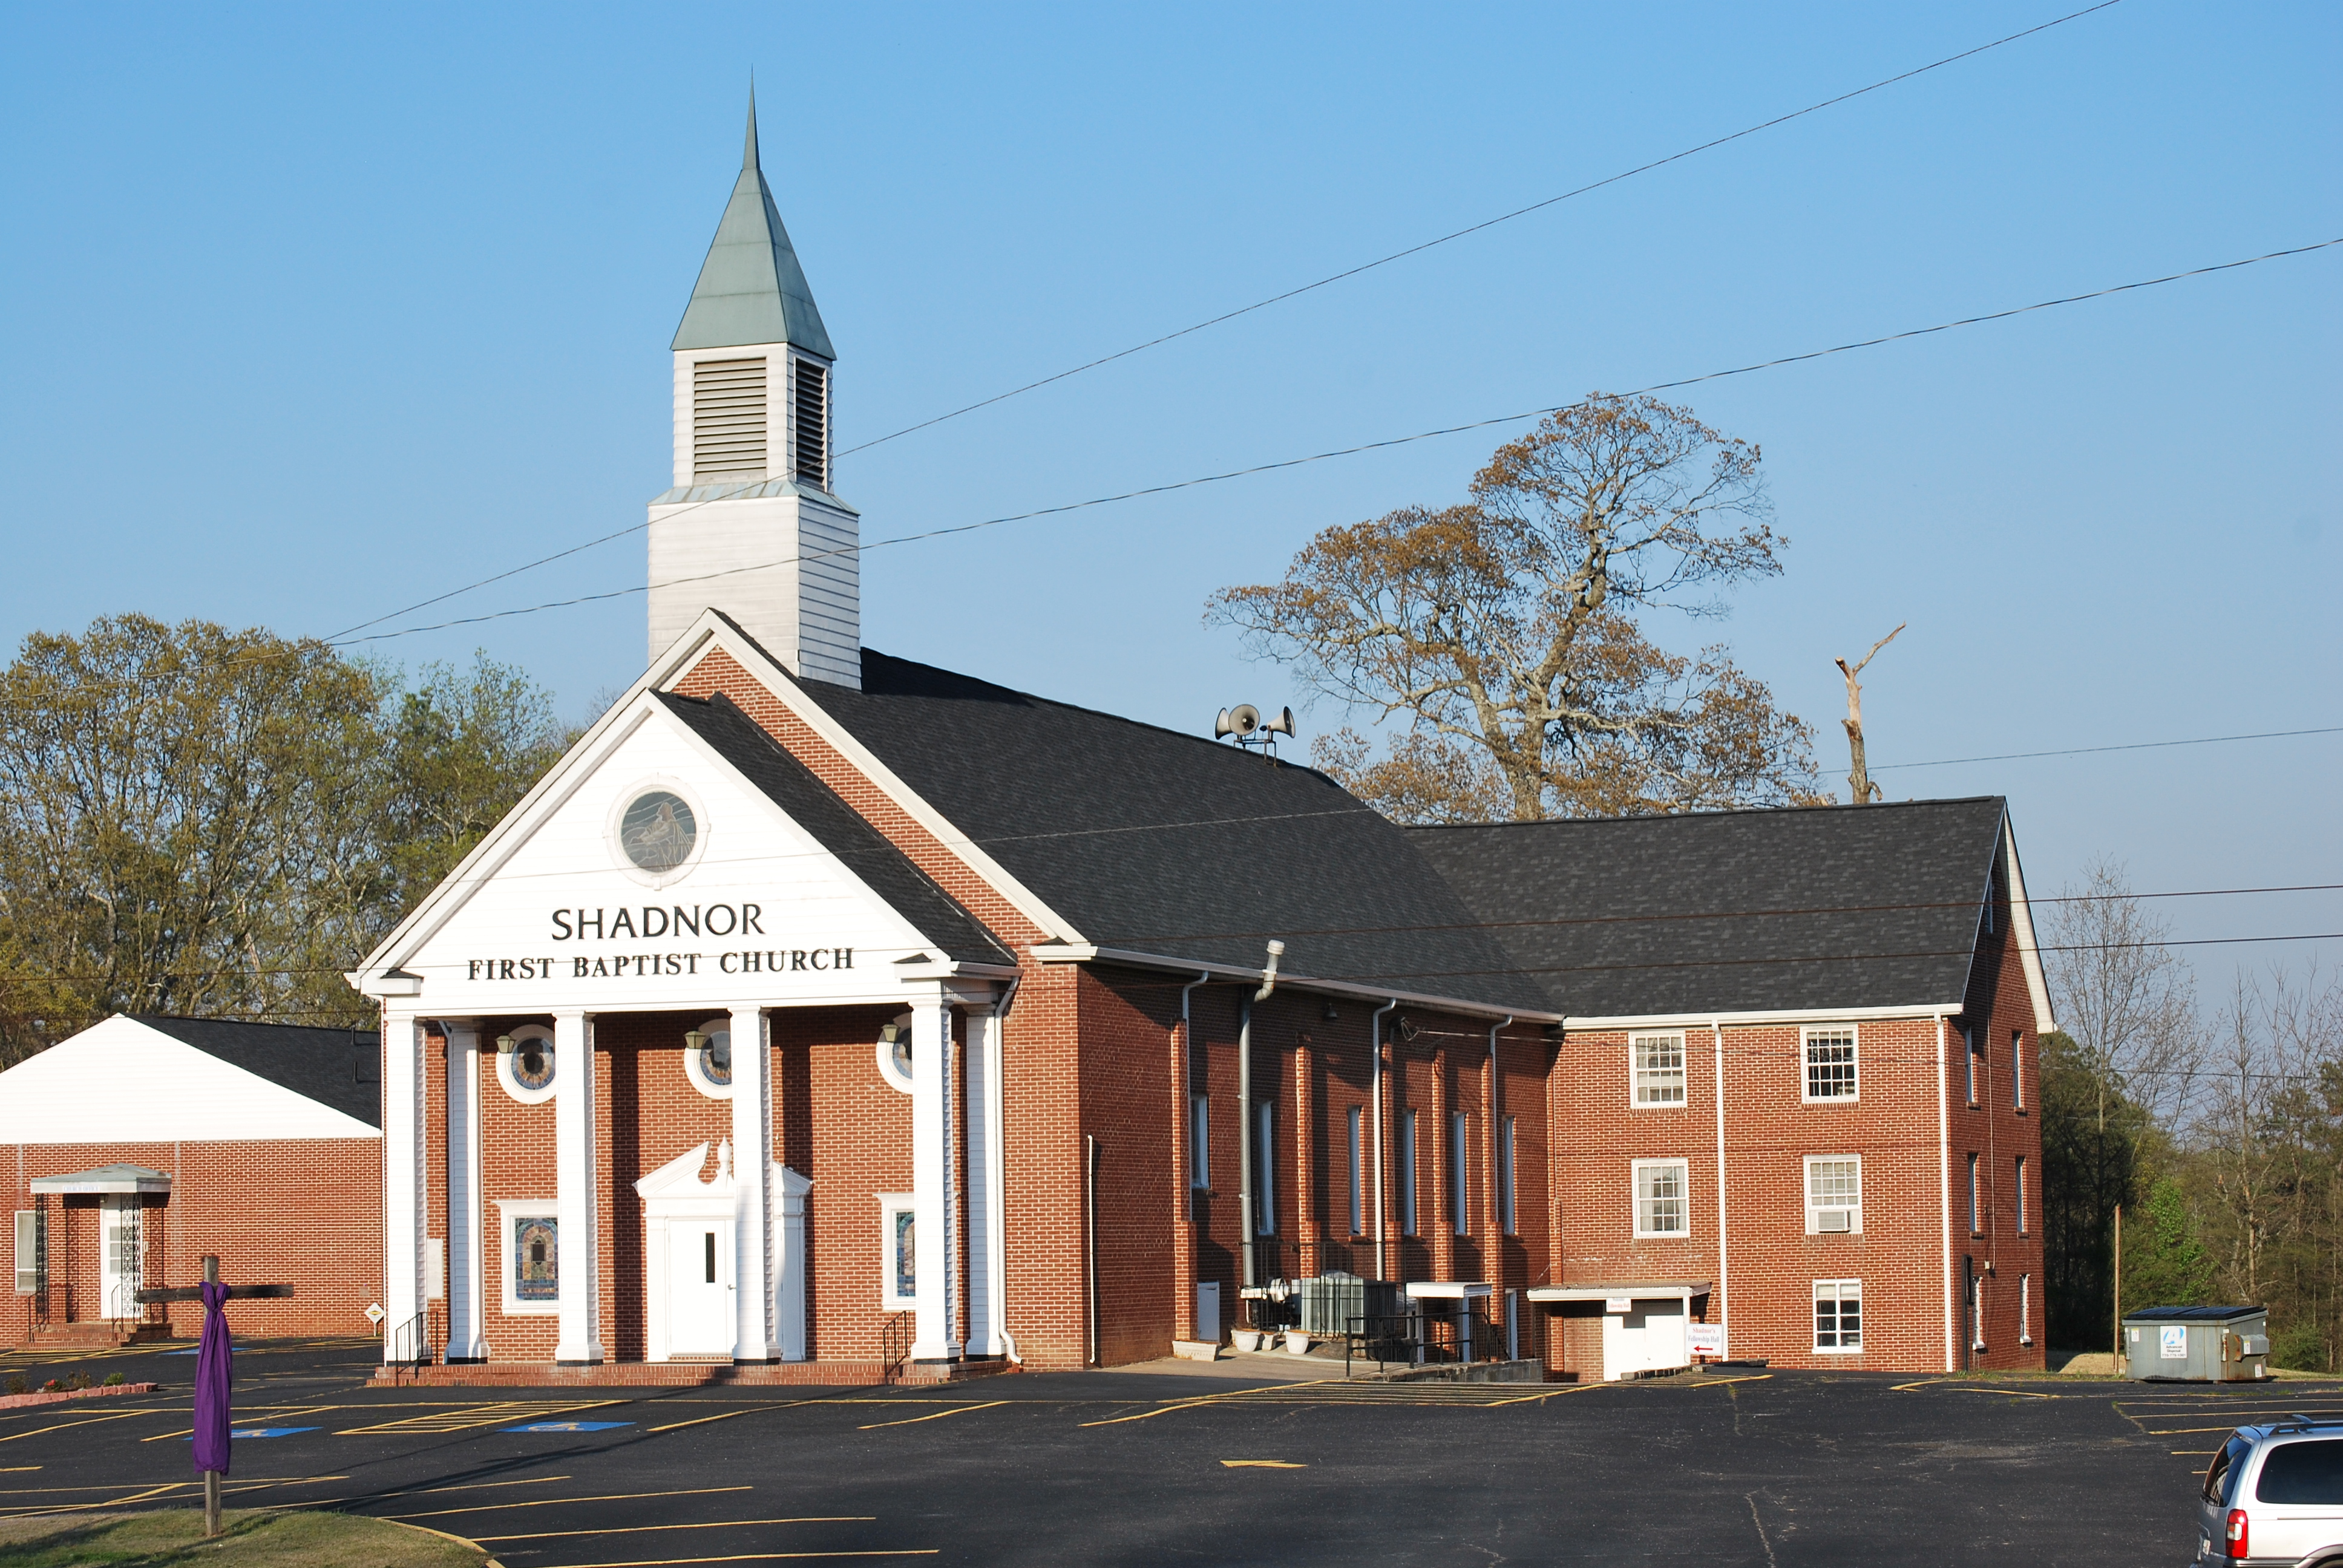

http://www.shadnorfbc.org

