SHADNOR FIRST BAPTIST CHURCH
770-964-6105
November 30, 2014

Pastor Rev. Wendell Burdette
Worship Leader Rev. Tommy Worthey
Organist Mrs. Shelby Poucher Pianist Mrs. Patty Burdette Ministry Assistant Mrs. Sherrie Stuart

MORNING WORSHIP
11:00 a.m.

"Brothers and sisters, whatever is true, whatever is noble, whatever is right, whatever is pure, whatever is lovely, whatever is admirable - if anything is excellent or praiseworthy - think about such things." ( Philippians 4:8 )

Prelude Pianist and Organist
Call to Worship "O Come, All Ye Faithful"
Hymn 4 "To God Be the Glory"
Opening Prayer
Hymn 227 "Praise Him! Praise Him!"
Welcome and Announcements Rev. Wendell Burdette
Hymn 426 "Victory in Jesus"
Offering
Offertory Instrumentalists
Special
Fellowship Hymn 95 "Go, Tell It on the Mountain"
Communion
Message Rev. Wendell Burdette
"Walking with God"
Psalm 63:1-8, 42:1-2, 37

Invitation Hymn 294 Have Thine Own Way, Lord"
Benediction Hymn 359 "This Is the Day"
Postlude Pianist and Organist


Thank you for joining us for worship today! Each week, we look forward to meeting together and encountering the Lord through worship. If you are a guest, Welcome! Please let us know of your visit by filling out the card located in the pew. Simply drop the card in the offering plate later in the service so that we can follow up with your visit and better serve you. Again, thanks for joining us for this time of worship!
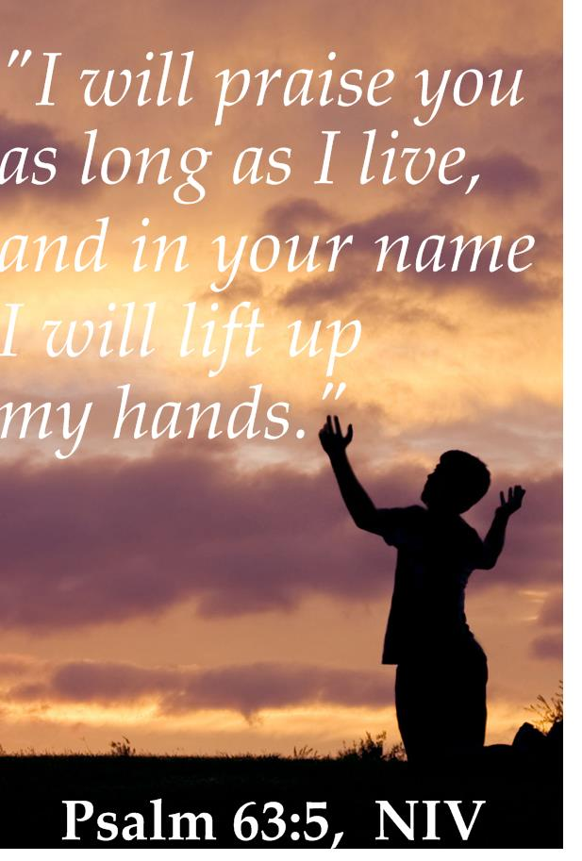




Dec. 1-7 Week of Prayer for Lottie Moon
International Missions - Our Goal - $1300

Monday - December 1, 2014
10:30 AM - WMU Meeting
Wednesday - December 3, 2014
4:30 PM - Bible Study
Wednesday - December 10, 2014
4:30 PM - Bible Study
Sunday - December 14, 2014
11:00 AM - Christmas Cantata
& Christmas Lunch!
Wednesday - December 17, 2014
4:30 PM - Church Conference
Wednesday - December 24, 2014
Christmas Eve!
No Mid-Week Services
Thursday - December 25, 2014
Christmas Day!

Pastor Contact Information:
Pastor: Rev. Wendell Burdette
Office:770-964-6105; Home: 770-253-8604;
Cell: 404-931-3925
Email: WendellBurdette@gmail.com
Website: http://www.shadnorfbc.org

SHADNOR FIRST BAPTIST CHURCH
6320 Westbrook Avenue
Union City, GA 30291
Telephone: 770-964-6105

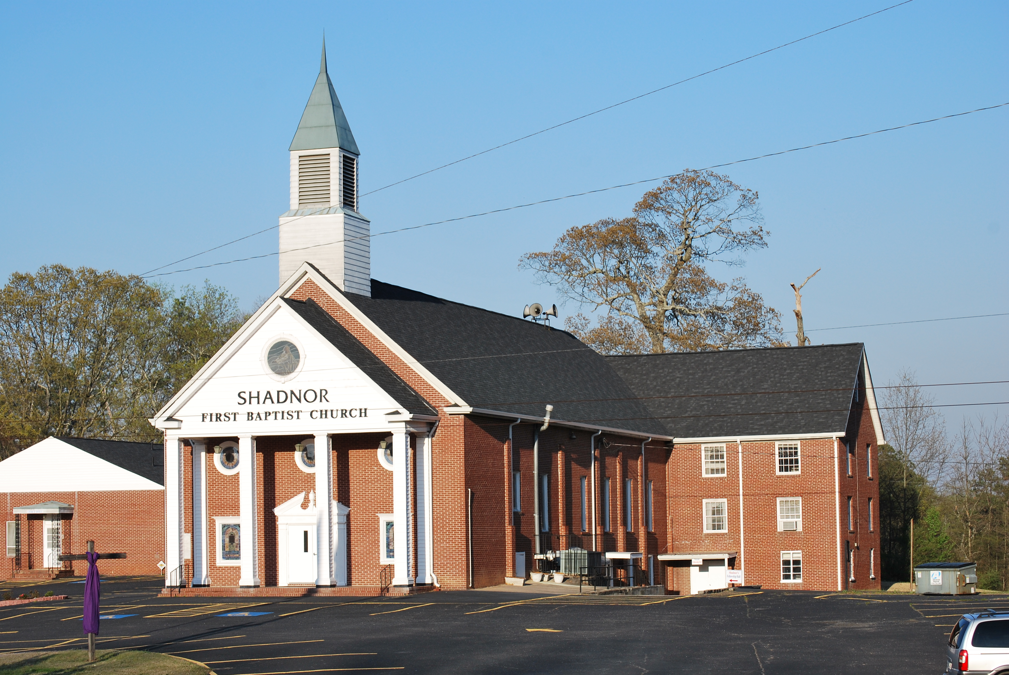

http://www.shadnorfbc.org

