SHADNOR FIRST BAPTIST CHURCH
770-964-6105
November 23, 2014

Pastor Rev. Wendell Burdette
Worship Leader Rev. Tommy Worthey
Organist Mrs. Shelby Poucher Pianist Mrs. Patty Burdette Ministry Assistant Mrs. Sherrie Stuart

MORNING WORSHIP
11:00 a.m.

"Praise be to the God and Father of our Lord Jesus Christ! In his great mercy he has given us new birth into a living hope through the resurrection of Jesus Christ from the dead, and into an inheritance that can never perish, spoil or fade...kept in heaven for you." ( 1 Peter 1:3-4 )

Prelude Pianist and Organist
Call to Worship "Majesty"
Hymn 644 "Count Your Blessings"
Opening Prayer
Hymn 15 "Come, Thou Fount of Every Blessing"
Welcome and Announcements Rev. Wendell Burdette
Hymn 485 "Stand Up, Stand Up for Jesus"
Offering
Offertory Instrumentalists
Special
Fellowship Hymn 386 "The Family of God"

Message Rev. Wendell Burdette
"Being Thankful in Tough Times"
Philippians 4:6-8 & Matthew 6:34

Invitation Hymn 307 "Just As I Am"
Benediction Hymn 426 "Victory in Jesus"
Postlude Pianist and Organist


Thank you for joining us for worship today! Each week, we look forward to meeting together and encountering the Lord through worship. If you are a guest, Welcome! Please let us know of your visit by filling out the card located in the pew. Simply drop the card in the offering plate later in the service so that we can follow up with your visit and better serve you. Again, thanks for joining us for this time of worship!

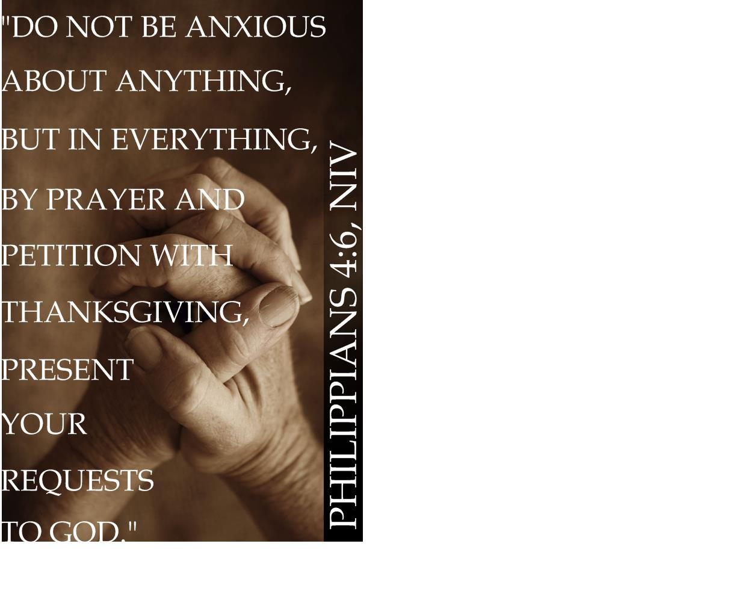



Wednesday - November 26, 2014
No Mid-Week Services
Thursday - November 27, 2014
Thanksgiving Day!

Dec. 1-7 Week of Prayer for Lottie Moon
International Missions - Our Goal - $1300

Monday - December 1, 2014
10:30 AM - WMU Meeting
Wednesday - December 3, 2014
4:30 PM - Bible Study
Wednesday - December 10, 2014
4:30 PM - Bible Study
Sunday - December 14, 2014
11:00 AM - Christmas Cantata
& Christmas Lunch!
Wednesday - December 17, 2014
4:30 PM - Church Conference
Wednesday - December 24, 2014
Christmas Eve!
No Mid-Week Services
Thursday - December 25, 2014
Christmas Day!

Pastor Contact Information:
Pastor: Rev. Wendell Burdette
Office:770-964-6105; Home: 770-253-8604;
Cell: 404-931-3925
Email: WendellBurdette@gmail.com
Website: http://www.shadnorfbc.org

SHADNOR FIRST BAPTIST CHURCH
6320 Westbrook Avenue
Union City, GA 30291
Telephone: 770-964-6105

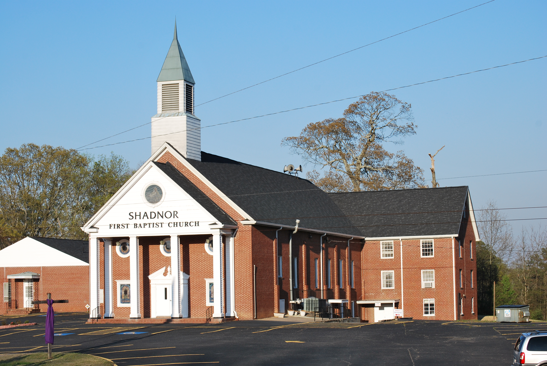

http://www.shadnorfbc.org

