SHADNOR FIRST BAPTIST CHURCH
770-964-6105
November 2, 2014

Pastor Rev. Wendell Burdette
Worship Leader Rev. Tommy Worthey
Organist Mrs. Shelby Poucher Pianist Mrs. Patty Burdette Ministry Assistant Mrs. Sherrie Stuart

MORNING WORSHIP
11:00 a.m.

"The heavens tell the glory of God, and the skies announce what his hands have made" ( Psalm 19:1 )

Prelude Pianist and Organist
Call to Worship "Amazing Grace"
Hymn 4 "To God Be the Glory"
Opening Prayer
Hymn 15 "Come, Thou Fount of Every Blessing"
Welcome and Announcements Rev. Wendell Burdette
Hymn 189 "The Lily of the Valley"
Offering
Offertory Instrumentalists
Choir "The Love of God"
Fellowship Hymn 346
"He's Got the Whole World in His Hands"

Message Rev. Wendell Burdette

"The Church Moved by Compassion"
John 15:12-13 & 2 Corinthians 5:14-15

Invitation Hymn 134 "Jesus Paid It All"
Benediction Hymn 478 "Seek Ye First"

Postlude Pianist and Organist


Thank you for joining us for worship today! Each week, we look forward to meeting together and encountering the Lord through worship. If you are a guest, Welcome! Please let us know of your visit by filling out the card located in the pew. Simply drop the card in the offering plate later in the service so that we can follow up with your visit and better serve you. Again, thanks for joining us for this time of worship!

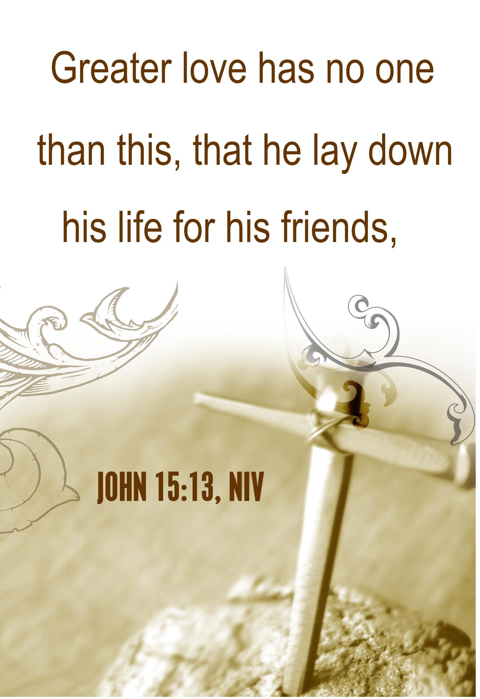





Wednesday - November 5, 2014
6:30 PM - Bible Study
7:15 PM - Deacons' Meeting
Tuesday - November 11, 2014
10:30 AM - WMU Meeting
Veteran's Day!
Wednesday - November 12, 2014
6:30 PM - Bible Study
Wednesday - November 19, 2014
5:30 PM - Church Supper
6:30 PM - Church Conference
Sunday - November 23, 2014
11:00 AM - Communion!
Wednesday - November 26, 2014
No Mid-Week Services
Wednesday - November 27, 2014
Thanksgiving Day!

Pastor Contact Information:
Pastor: Rev. Wendell Burdette
Office:770-964-6105; Home: 770-253-8604;
Cell: 404-931-3925
Email: WendellBurdette@gmail.com
Website: http://www.shadnorfbc.org

SHADNOR FIRST BAPTIST CHURCH
6320 Westbrook Avenue
Union City, GA 30291
Telephone: 770-964-6105

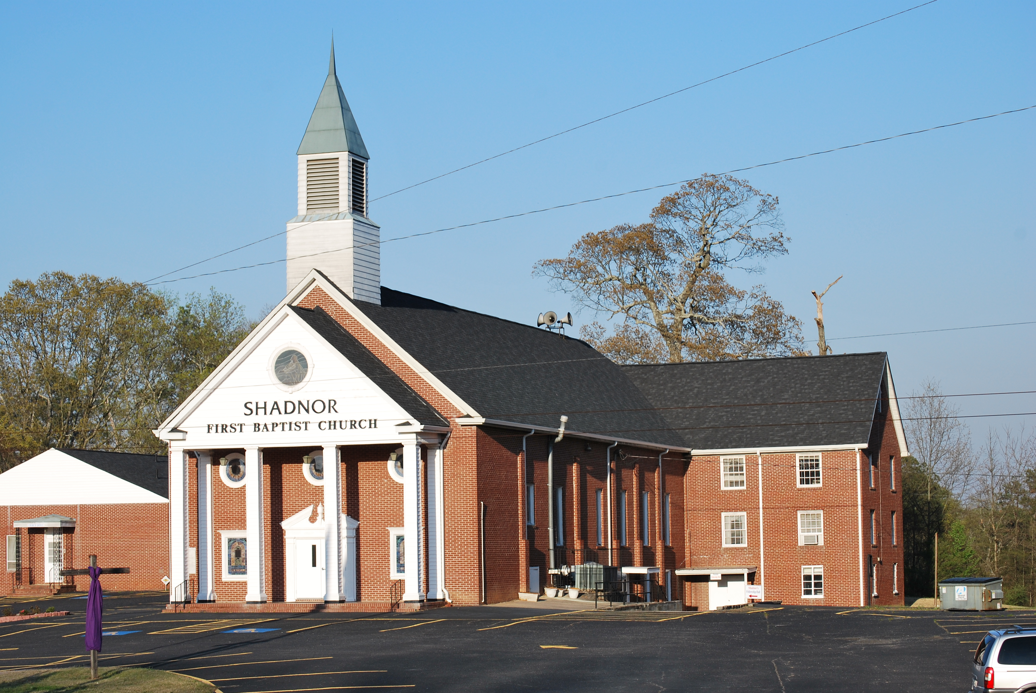

http://www.shadnorfbc.org

